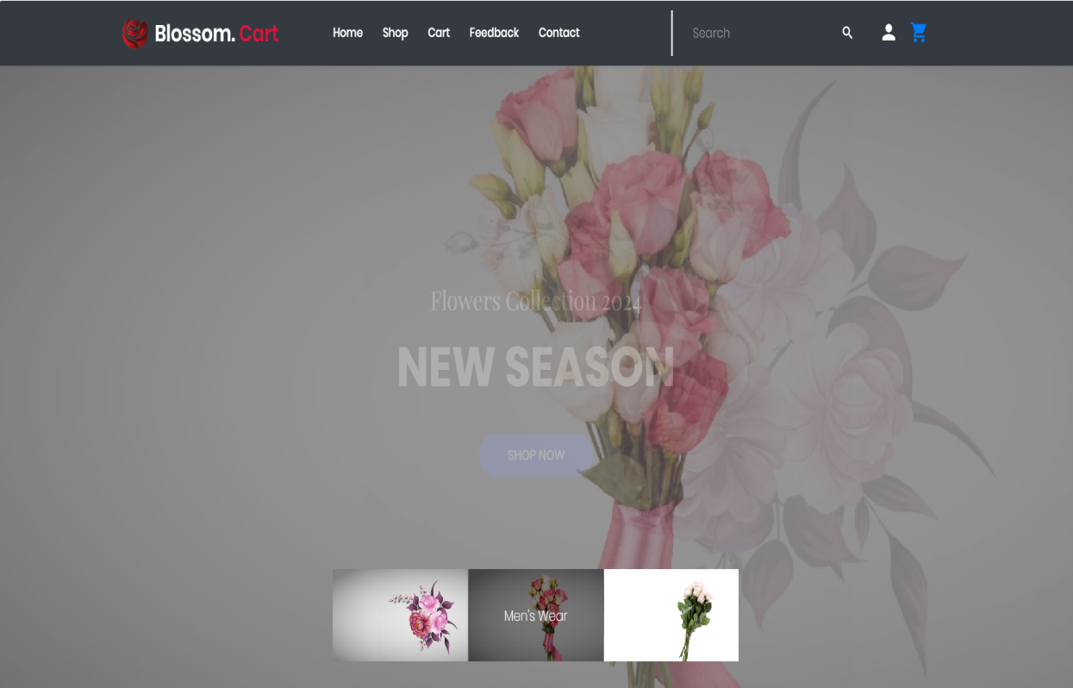

| **Supervisor** | SIR HARISS NASEER | |
| --- | --- | --- |
| **Batch** | 2301b2 | |
| **Group** | **A** | |
| **Serial No.** | **Enrollment Number** | **Student Name** |
| 1. | Student1451599 | MUHAMMAD AHMED IDRESS |
| 2. | Student1449717 | MUHAMMAD MOHSIN MUKHTIAR |
| 3. | Student1448755 | MUHAMMAD QSAIM MUSTAFFA |
| 4. | Student1448145 | EMANNUAL |
| 5. | Student1398610 | SYED MINHAJ UDDIN |
|  | Student1449714 | HASEEB AHMED |
|  |  |  |

1.Home(index.html):

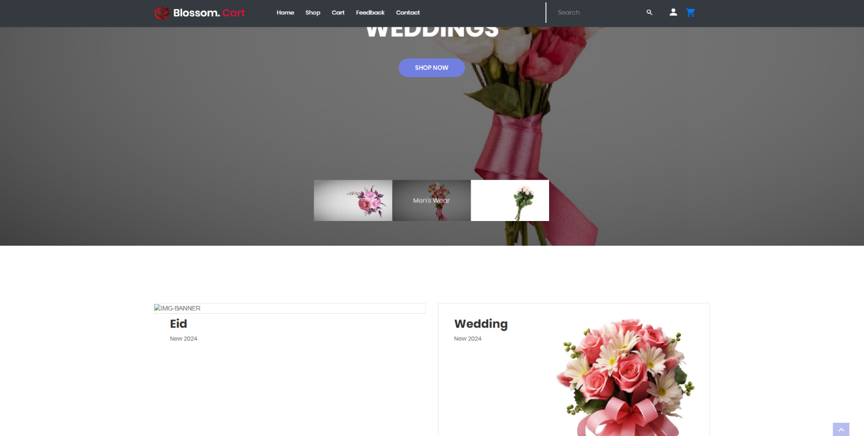

* By clicking the logo, the user will be taken to the homepage.
* Using the navbar, the user can navigate through various categories.

2.Navbar(index.html):



* There are four essentials listed here, and you will be redirected to the specified pages.

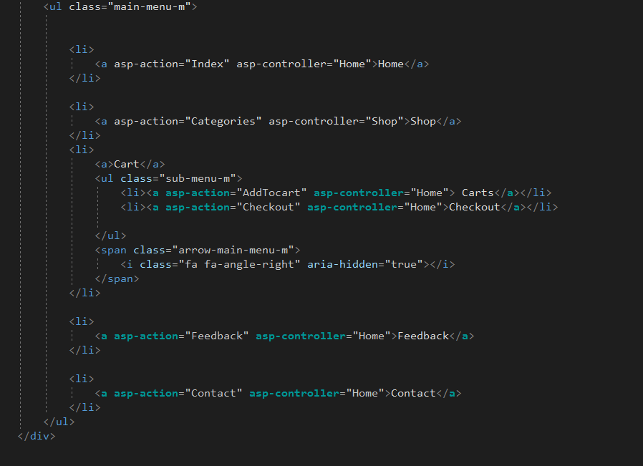

3.Add to cart(index.html): 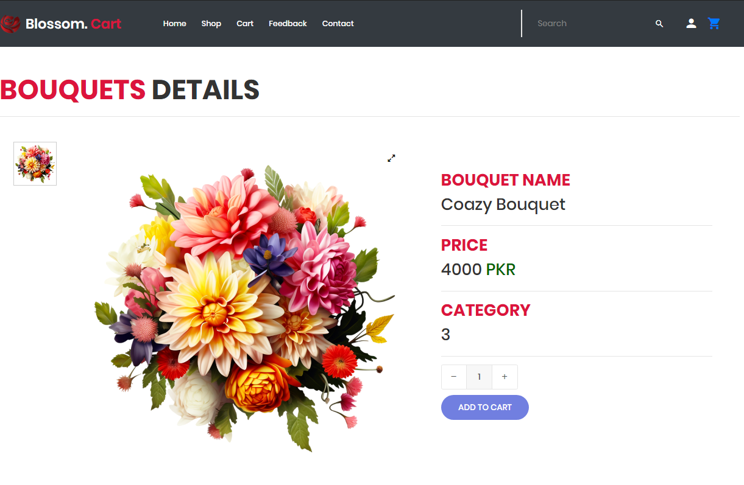

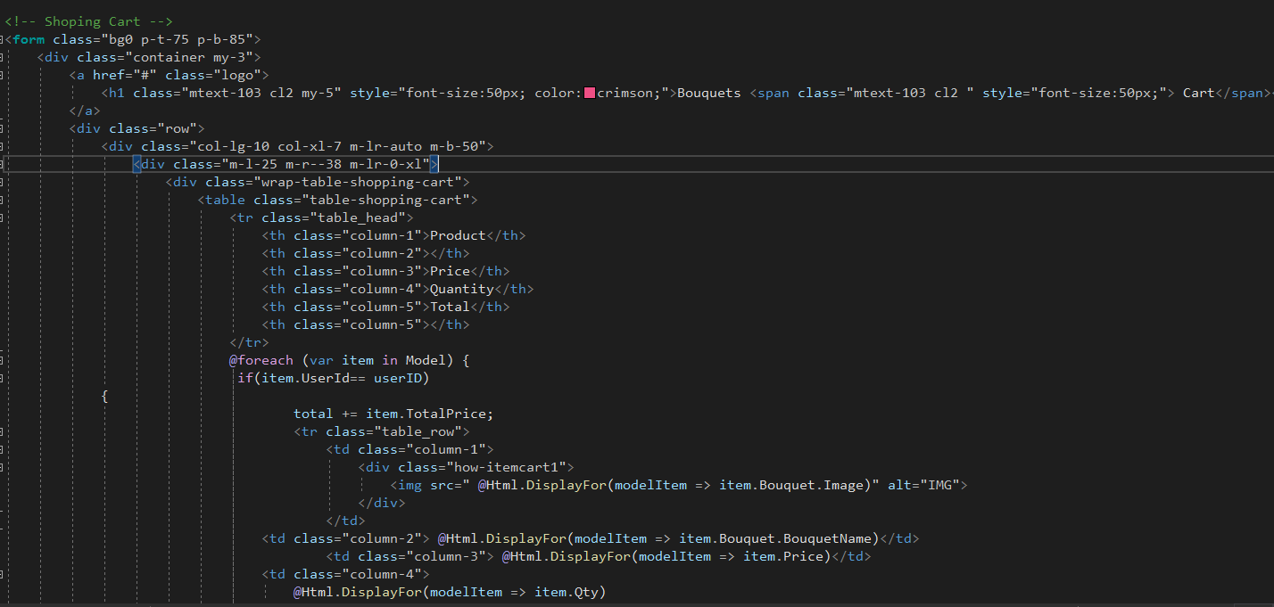

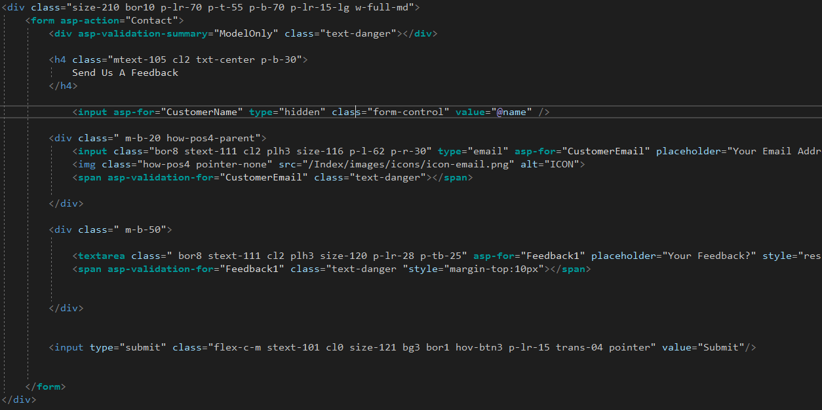

5.Contact Us(ContactUs.html): 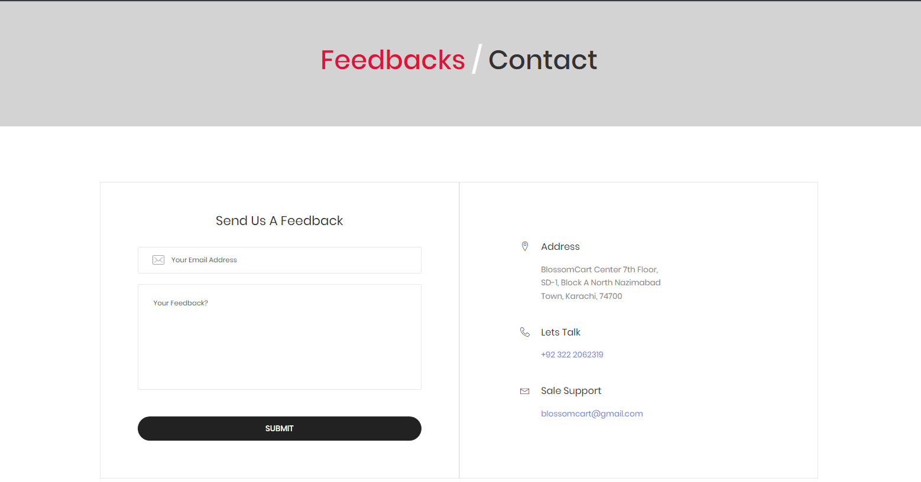

6.Log In & Sign Up form (form.html):

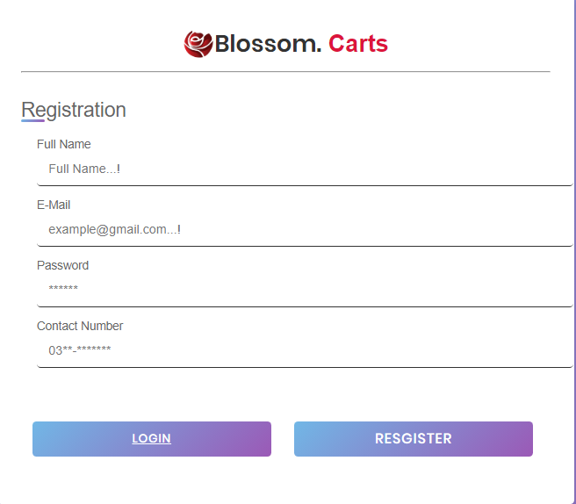

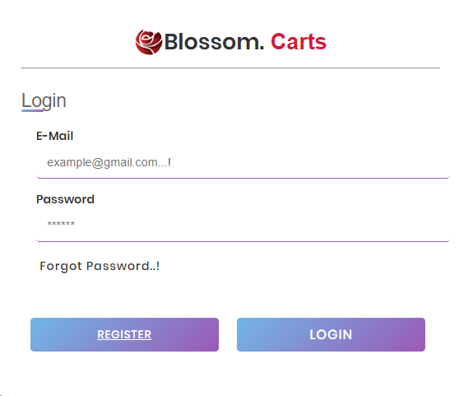

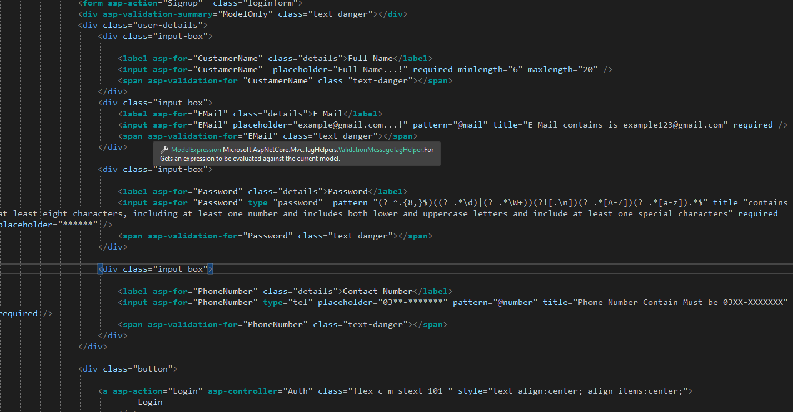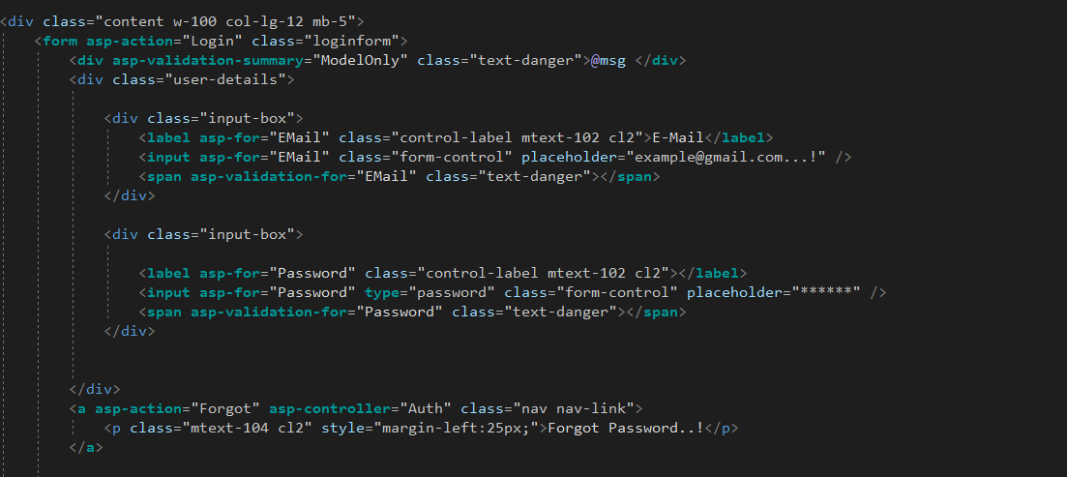

8.Footer:

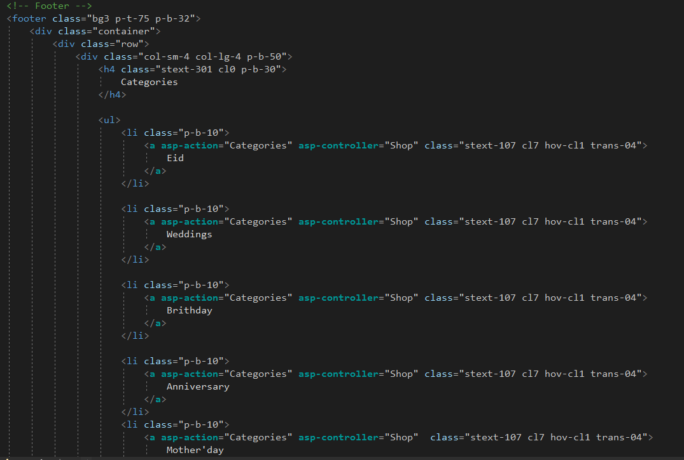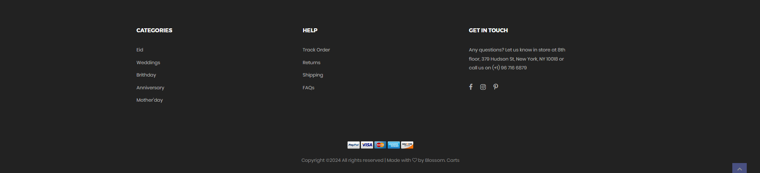

Summary:

The Blossom Carts Website Developer Guide is an essential resource for developers tasked with creating and maintaining the Blossom Carts website. This guide provides all the necessary information to build, test, and launch the online flower shop, including technical requirements, coding standards, and best practices.

Once the development environment is set up, the guide details how to implement various features of the Blossom Carts website, such as the user interface, the order processing system, and inventory management. It offers step-by-step instructions and examples to help developers effectively understand and implement each functionality.

In summary, the Blossom Carts Website Developer Guide is a thorough resource designed to ensure the successful development, testing, and launch of the Blossom Carts online flower shop.